**How to Host Web Pages on GitHub**

1. Go to <http://github.com> and sign up for an account.
2. 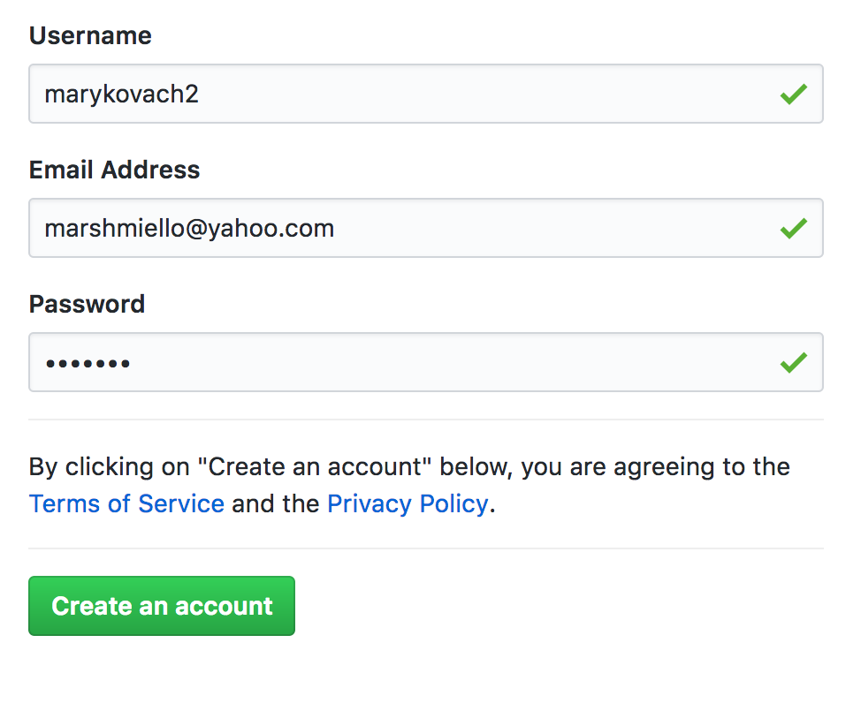Choose a username and password, and click “Create an account.”
3. 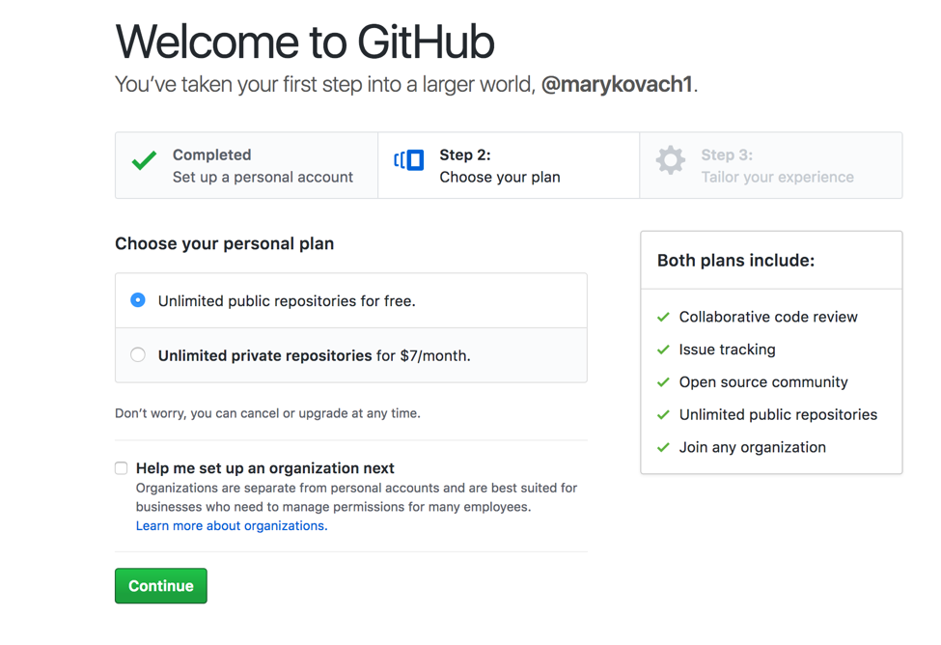Keep the default options and click “Continue.”
4. You can either fill out the survey and click “Submit,” or choose “skip this step.”
5. You will receive an email verification message. Go to your email and click the link to verify.

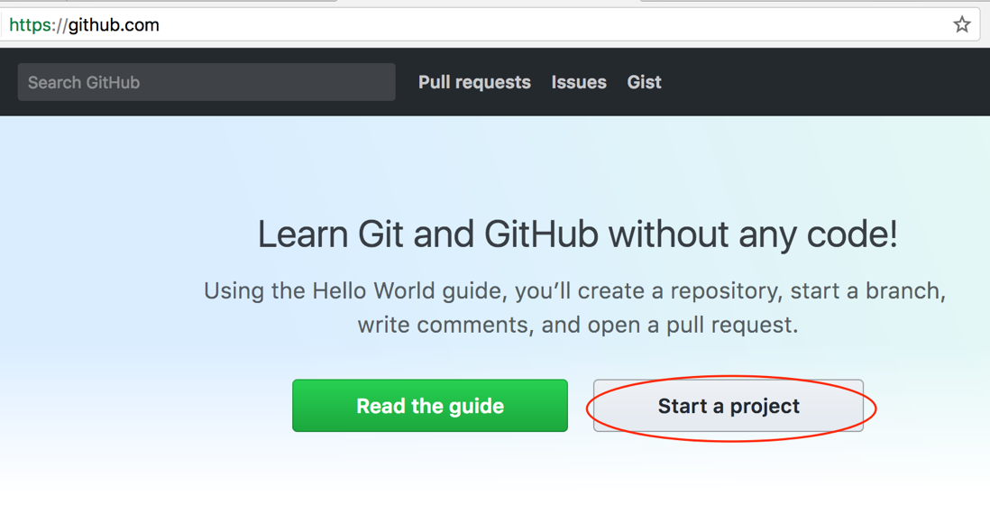

1. Once you have verified your email account, you can “Start a Project.”

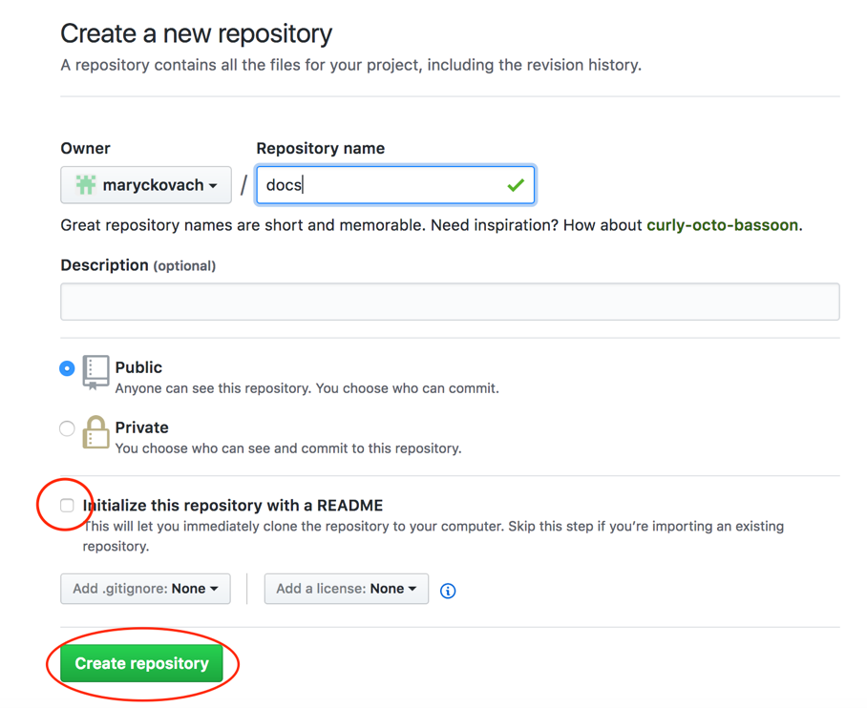

1. Name your Repository, keep it as Public, and **be sure to put check mark where it reads “Initialize this repository with a README.”** Then, click “Create repository.”
2. To set up your project for web pages, go to the “Settings” tab at the far right.



1. Scroll down to the “GitHub Pages” section of the Settings. Click on the dropdown next to “None,” and choose “master branch.” Then click “Save.”

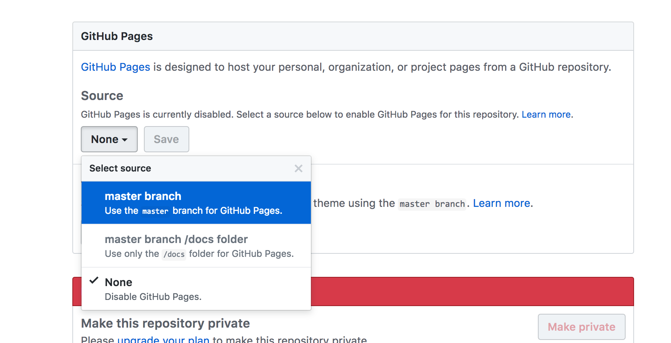

1. 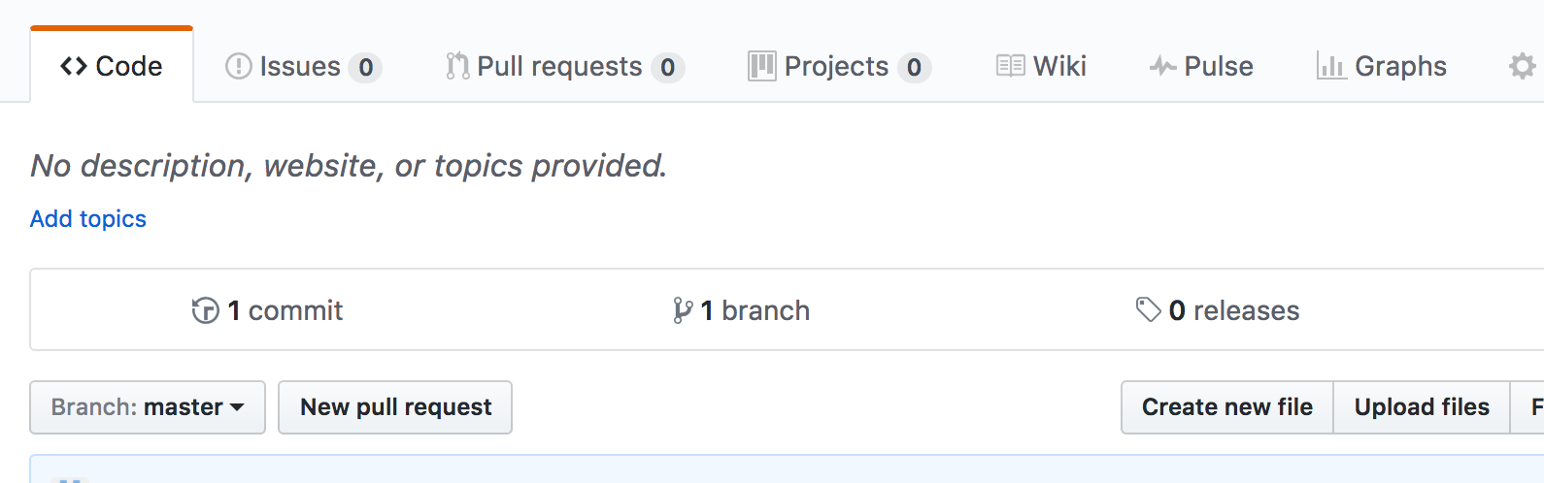Click back on the “Code” section at the top of the page. You can now click “Upload files” to upload folders containing your web page elements.
2. You can now drag your entire folder into the upload area (all of your html files and associated project images should be included in this same folder).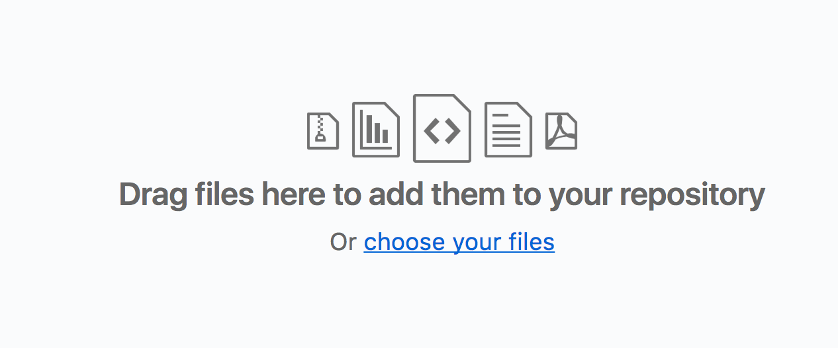

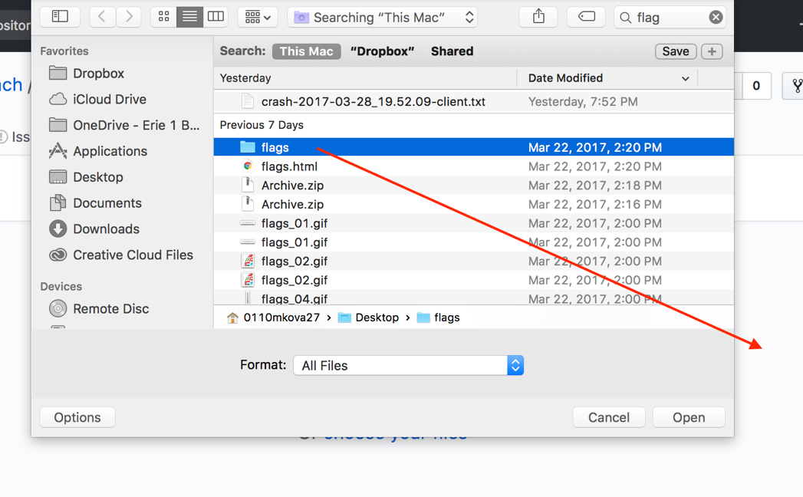

1. 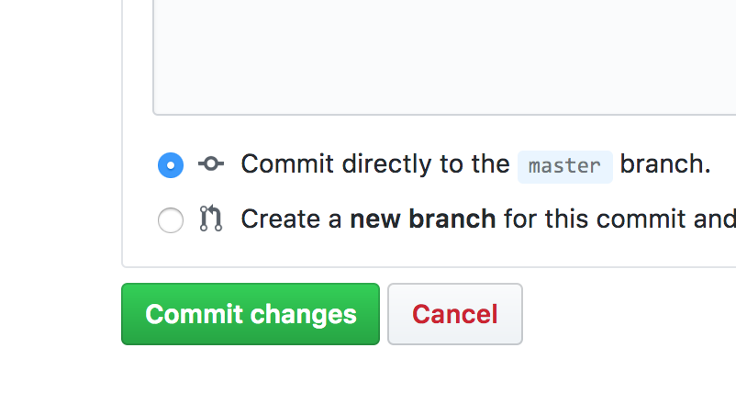Once you have dragged your folder in, be sure to click “Commit changes” at the bottom of the page.
2. To view your pages online, go to: https://***yourusername***.github.io/***your repositoryname***/***yourfoldername***/***yourfilename***.html

Here is an example URL: <https://maryckovach.github.io/new/flags/flags.html> (click on Canada, Great Britain, or Japan to preview hyperlink functionality).